AI Camera 2.0 Basic Projects

Lesson 9: Object-Following Car
Ages: 12 and up
Duration: 45 minutes

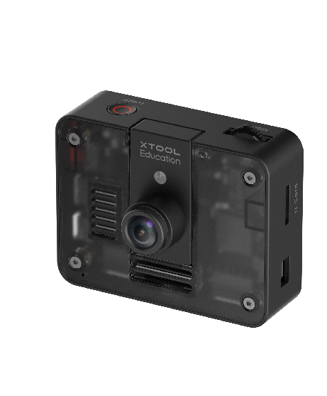

Objectives:
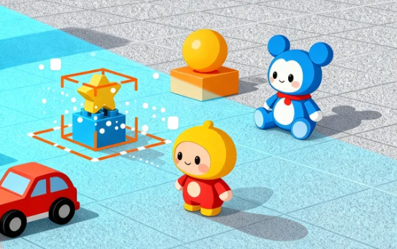
By the end of class, students will be able to:
- Understand the basic principles and technical features of object recognition
- Master the programming implementation of the AI Camera's object detection function
- Program the mBot2 to automatically follow a target object

Overview
This course uses a robot following a human figure as an example to guide students in exploring the object recognition capabilities of the AI Camera. Students will learn how to use the camera to detect targets and program the mBot2 robot to follow moving objects. The course covers the complete technological chain from visual detection to motion control, allowing students to experience the practical application of artificial intelligence in mobile robotics and understand the synergistic working principles of target detection and robot control.

Pre-lesson Checklist
For the teacher:
- Computer with mBlock installed and tested;
- Adequate number of mBot2 robots (fully charged);
- AI Cameras compatible with mBot2;
- CyberPi and connection cables;
- Printed 3D character boards;
- Open testing area (ensuring safe movement space);
For the students:
- Computer with mBlock installed and ready;
- mBot2 robot and AI camera set per group;
- CyberPi and connection cable;
- Sufficient number of 3D character boards;
- Reserved adequate space for testing and experimentation;
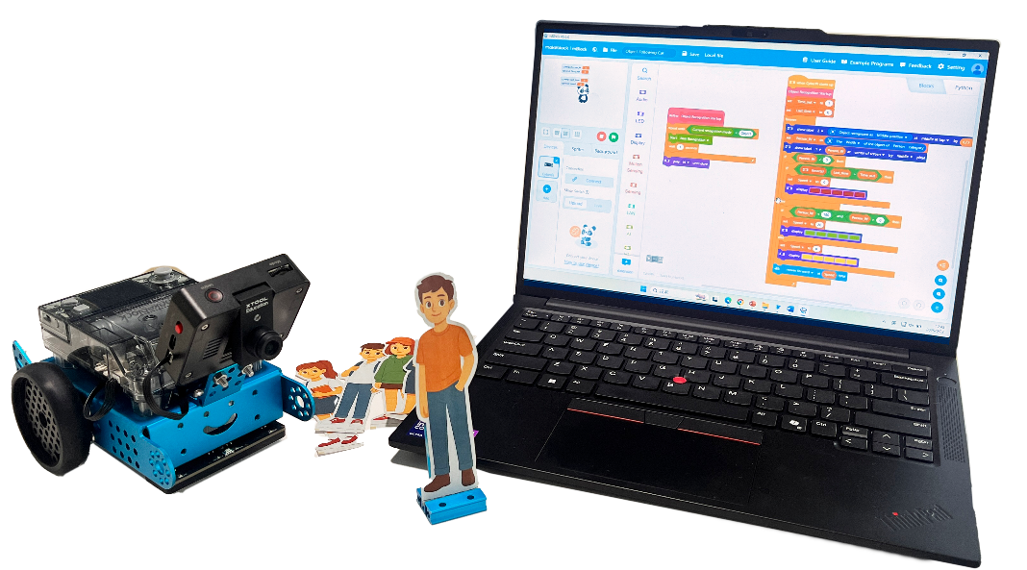

Agenda (45minutes)
Duration | Content
5 minutes | Section 1 - Introduction  - Demonstrate controlling the car's ability to follow a 3D character board;  - Prompt interaction: “How does the car 'see' and 'follow' the movement of the 3D character board?"
10 minutes | Section 2 - Explore  - Understand the basic principles of object recognition: feature extraction and classification;
15 minutes | Section 3 - Create and practice  - Set up the programming environment and activate the object recognition function;  - Program to achieve recognition of the 3D character board and obtain relevant parameters;  - Design the automatic following control logic for the mBot2;
10 minutes | Section 4 - Presentation  - Invite 2-3 groups of students to demonstrate their automatic following robots;  - Discuss what other creative applications can be developed using object recognition technology;
5 minutes | Section 5 - Evaluate  - Review the problems they met and how they solved;  - Explore other potential application scenarios for object recognition technology;

Activities

Section 1 - Introduction
In today's lesson, we will explore the object recognition technology of the AI Camera. Serving as the "visual sensor" for the mBot2 robot, the AI Camera can capture environmental images in real time and identify specific targets within them. Through advanced visual algorithms, it not only detects the presence of objects but also precisely analyzes key information such as object width, height, and coordinate position, providing a data foundation for intelligent tracking.

Section 2 - Explore
The AI Camera employs deep learning algorithms to identify human targets. This process begins with feature extraction, where the algorithm analyzes visual characteristics such as edges, contours, and textures within the image to capture distinctive patterns.
The system then proceeds to pattern recognition, comparing the extracted features against a vast dataset of training examples to identify human-specific characteristic patterns. This step enables the camera to distinguish human targets from other objects in the environment.
Finally, target localization precisely determines the object's position and size within the frame. This spatial information provides critical data for subsequent interactive applications and motion control decisions.

Section 3 – Create and practice
In this section, students will work in groups to build an mBot2 car capable of automatically detecting and following moving objects, functioning like a smart assistant.
Task 1: Set up the programming environment and activate object recognition
Step 1: Set up the programming environment. In the mBlock programming environment, click the [Extensions] button in the lower left corner and add the [AI Camera 2.0] and [mBot2 Shield] modules. | 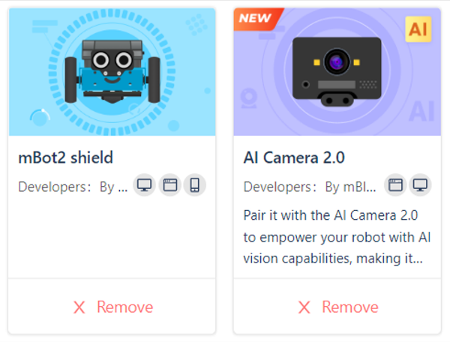
Step 2: Create object recognition startup function. Package the complex initialization steps into a custom function named [Object Recognition Startup]. This function serves as a quick command to ensure the AI Camera is ready for operation. | 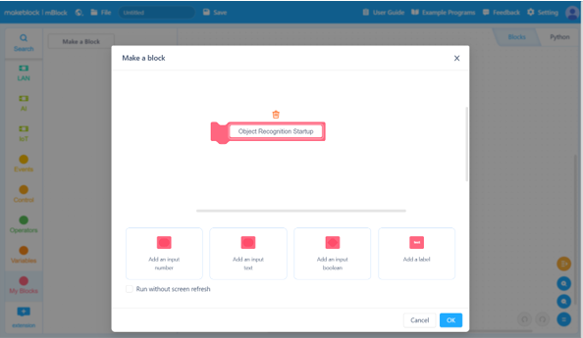

Task 2: Program object recognition and data acquisition
Step 3: Create essential variables. Create the following variables to store recognition data:  Person_W: Represents the width coordinate of the detected object.  Time_out: System delay time  Last_time: Last recognition timestamp  Speed: Controls mBot2 motion execution parameter adjustment | 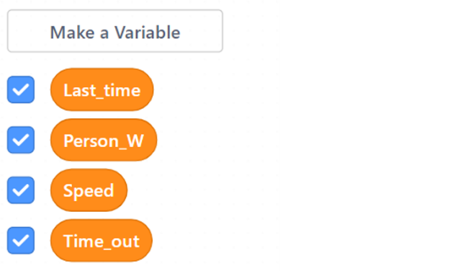
Step 4: Implement continuous recognition. Add a [forever loop] block to create the main program loop. Use the [get center object type] block within the loop to obtain Person_W for adjusting mBot2 motion parameters. | 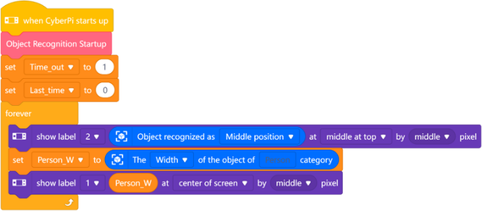

Task 3: Design mBot2 automatic following control logic
Step 5: Control mBot2 motion speed.  Dynamically adjust the car's running speed based on the Person_W variable (person recognition width) to achieve distance-adaptive control. Reduce speed when the person is closer and increase speed when farther away, achieving stable and smooth following performance. | 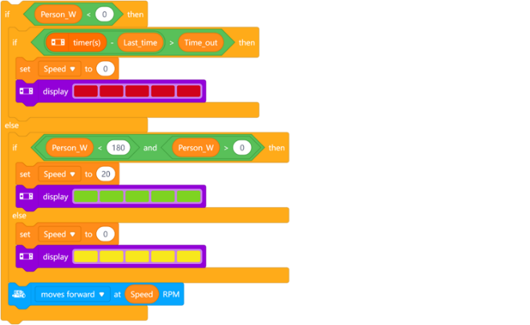

Section 4 - Presentation
In this session, students are invited to present and compare their group project outcomes. During demonstrations, each group should showcase the accuracy and stability of their object recognition system and share the challenges encountered during implementation. After 2-3 groups have presented, the teacher will facilitate a class discussion. Consider the following questions: What unique design features did different groups incorporate into their following cars? What other creative applications could be developed using object recognition technology?

Section 5 - Evaluate
Now let's review some key points in this lesson.
- What was the biggest challenge you faced in today's project? How did you and your team work together to solve it?
- What other potential applications could object recognition technology have in daily life?

